INTRODUCTION

In today’s digital world, secure communication has become very important due to the rapid growth of internet and multimedia data. Along with encryption, steganography plays a vital role in information security by hiding secret data inside digital media such as images, audio, and video.
Steganography using LSB in Image (Password Based Encryption) is a technique in which confidential text information is hidden inside a digital image in such a way that the existence of the hidden data is not noticeable to the human eye. This project uses the Least Significant Bit (LSB) method to embed secret text into a image while maintaining the original image quality.
In this system, the secret text is first encrypted using a password before embedding. The password acts as a security key, ensuring that only an authorized user can extract and read the hidden message. Even if an unauthorized person gains access to the stego image, the hidden data remains unreadable without the correct password.
The LSB technique works by modifying the least significant bits of the image pixels, which causes very minimal change in pixel values. Since these changes are visually imperceptible, the stego image appears almost identical to the original image. This makes LSB-based steganography an effective and efficient method for secure data hiding.
Thus, this project combines both steganography and password-based encryption to provide a double layer of security, ensuring confidentiality, integrity, and safe transmission of sensitive information.

TOOLS & TECHNIQUE

To implement the Steganography using LSB in Image (Password Based Encryption) system, the following tools and techniques were used:
Programming Language
- MATLAB
  - Used for implementing image processing, steganography algorithms, encryption, and GUI design.
  - Provides built-in functions for image handling and bit-level operations.

Frameworks and Toolboxes
- MATLAB Image Processing Toolbox
  - Used for reading, displaying, and manipulating digital images.
  - Supports RGB image processing and bit-plane slicing.
- MATLAB GUI Components (uifigure, uiaxes, uibutton, etc.)
  - Used to design a user-friendly graphical interface for embedding and extracting text.

Image Processing Techniques
- Least Significant Bit (LSB) Steganography
  - Secret data is embedded into the least significant bit of an image.
  - Ensures minimal visual distortion of the image.
- Bit-Plane Slicing
  - Used to visualize the LSB layer of the image.
  - Helps in understanding where the hidden data is stored.

Security Mechanisms Used
- Password-Based XOR Encryption
  - The secret text is encrypted using XOR operation before embedding.
  - The password acts as the encryption key.
  - The same password is required for successful decryption.
- Binary Encoding
  - Text characters are converted into 8-bit binary format before embedding.
  - Extracted binary data is converted back into readable text.

MEHODOLOGY

Step1: Image Selection and Preprocessing
The user selects an RGB image which is used as the cover image. Indexed images are converted to RGB format to ensure proper processing.

Step2: Secret Text and Password Input
The user enters the secret text along with a password, which acts as a security key.

Step3: Password-Based Encryption
The secret text is encrypted using XOR encryption with the given password to make the data unreadable.

Step4: Binary Encoding
The encrypted text is converted into 8-bit binary format for embedding.

Step5: LSB-Based Embedding
The binary data is embedded into the least significant bit of the red channel of the image, causing no visible change in image quality.

Step6: Stego Image Creation and Storage
The modified image containing the hidden data is saved as the stego image.

Step7: Data Extraction
The LSB bits are extracted from the red channel of the stego image to reconstruct the encrypted data.

Step8: Password-Based Decryption and Display
Using the same password, the encrypted data is decrypted to retrieve and display the original secret message.

OUTPUT
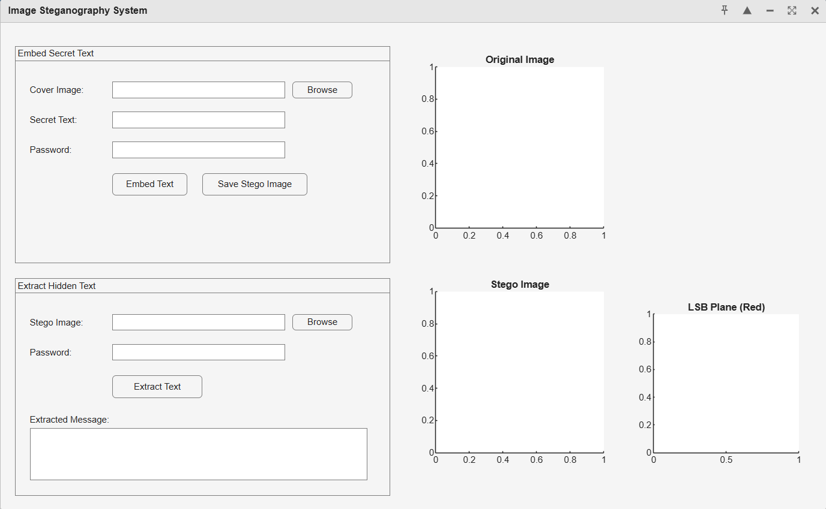

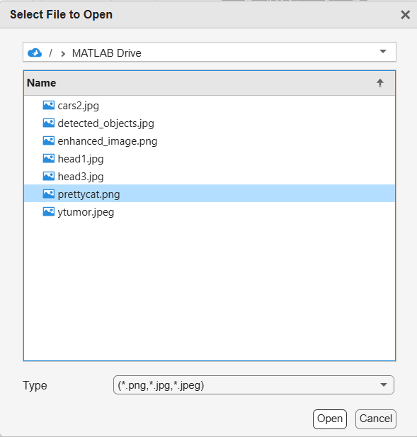
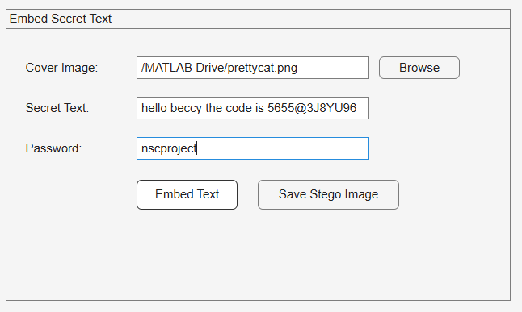

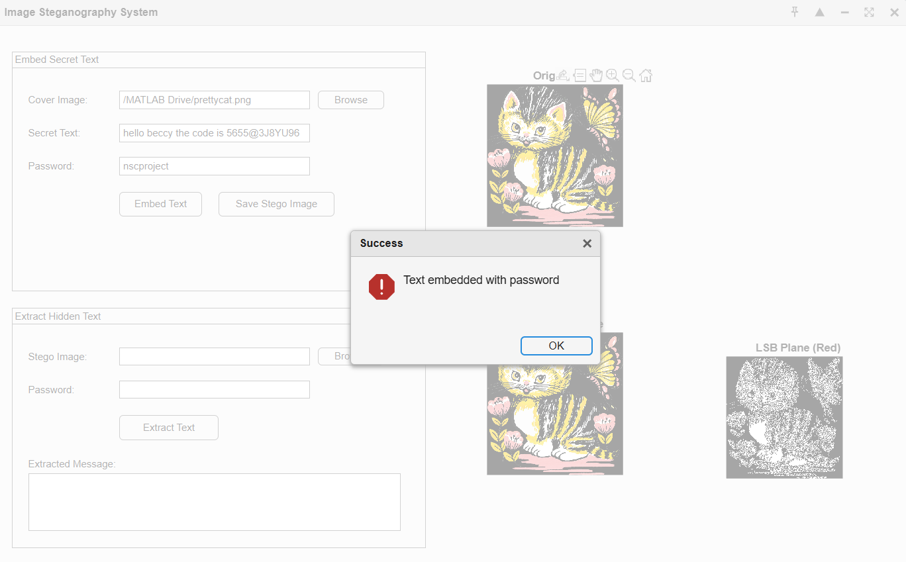

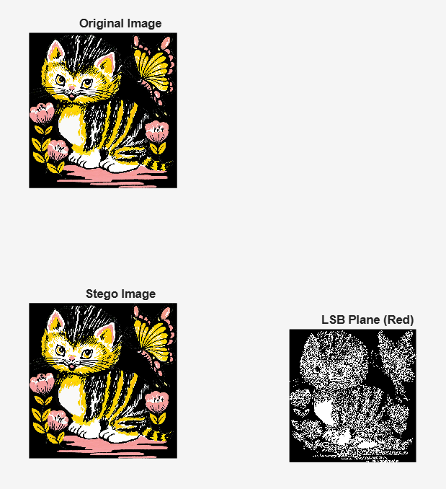

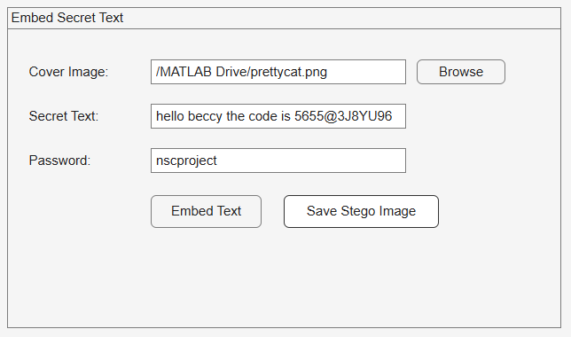
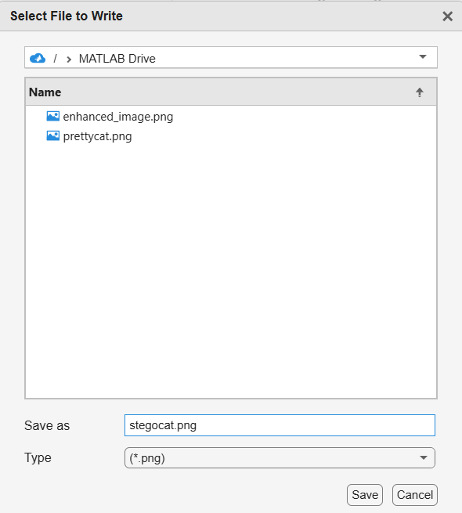

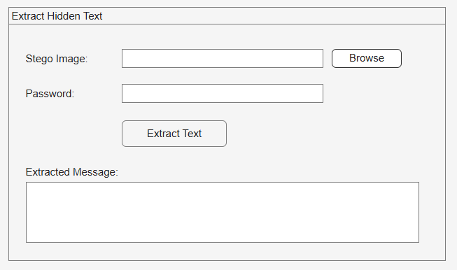

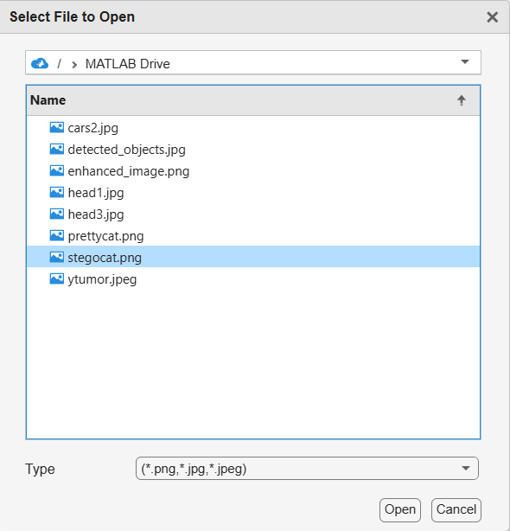

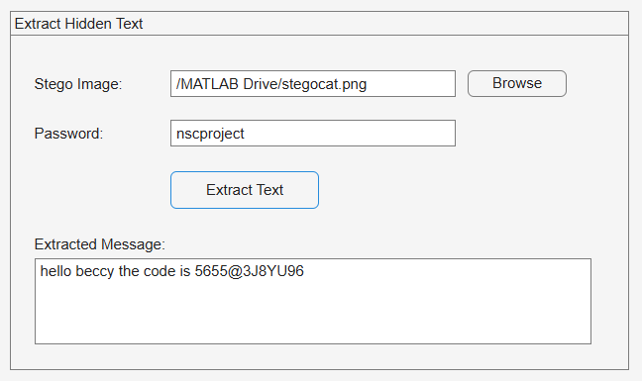

If the wrong password is given

